Holbeach and East Elloe
Hospital Trust
Owned and run by the community

Boston Road North,
Holbeach
Spalding
PE12 8AQ
01406 422283
www.holbeach-hospital.org.uk
info@holbeach-hospital.org.uk

2019

Holbeach and East Elloe Hospital
Nursing Home
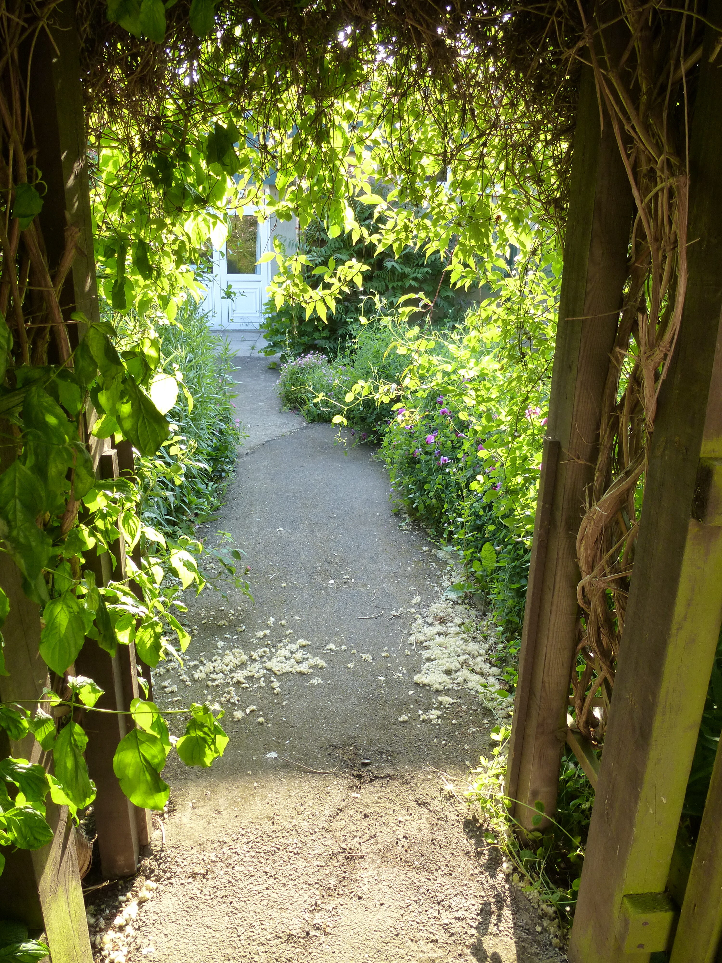

Welcome Pack

Contents
1. Staff
2. Dayrooms, family room and activities
3. Visitors
4. Optional extras and how to book them
5. Fire Policy & Electrical Equipment
6. Complaints Procedure

Notes

6. Complaints and Compliments
We make every effort to make sure that residents and patients are treated with great care and consideration when they visit the Hospital. However, if you are not happy with any aspect of the care provided and would like to make a complaint this should be made directly to the Manager or Deputy Manager.
If you are not satisfied after speaking with the Manager (or your complaint is about the Manager), you can make a written complaint to the Trust Chairman c/o Holbeach Hospital with the hospital’s address. Complaints received in writing to the Manager or Chairman will be considered within two days of receipt and subject to the depth of investigation required, will be responded to by the Trust Chairman or the Manager within a week.
If you are still dissatisfied with the outcome, you may ask The Local Government Ombudsman to investigate (Local Government Ombudsman, PO Box 4771, Coventry, CV4 0EH). The Local Government Ombudsman is a free, independent complaints service. The Ombudsman will provide a single investigator who can look at the whole case. They cannot investigate every complaint but will carry out an initial assessment to find out:
- what is being complained about
- the organisations involved
- if there are barriers to them investigating

They will let you know the outcome of the assessment as soon as they can. If your complaint can be investigated, it will then be allocated to an investigator who will carry out the detailed investigation work.
We also want to know when we get it right! We welcome compliments and will let staff know when you think they have done a good job.
1. Staff
You will be able to recognise our staff by the uniform they wear.
Senior Care Assistants
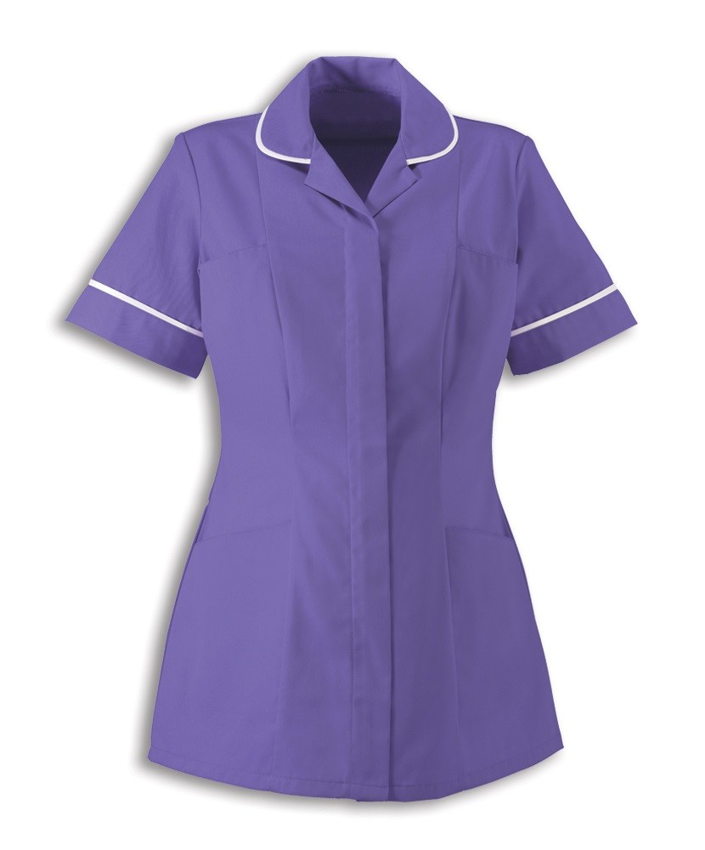
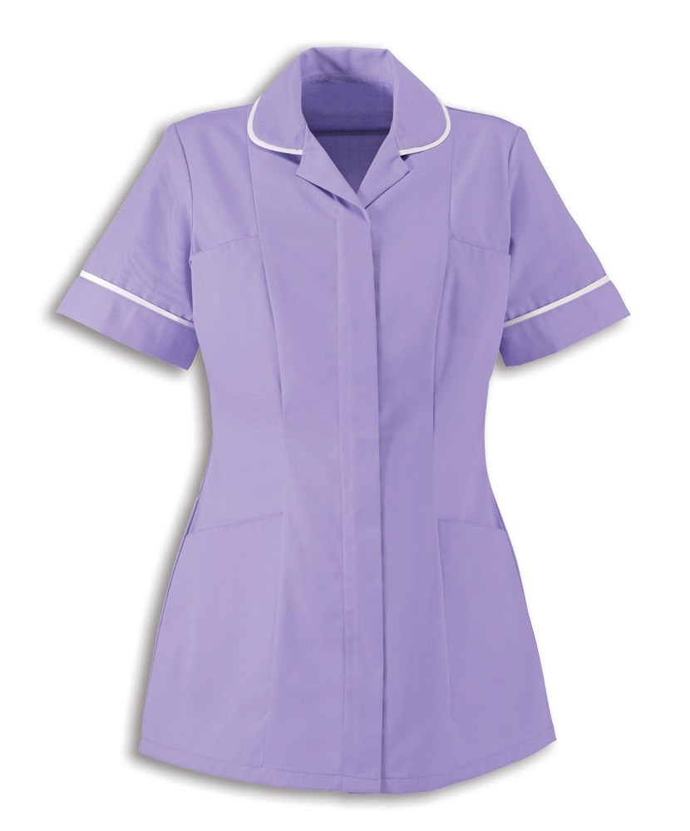
Care Assistants
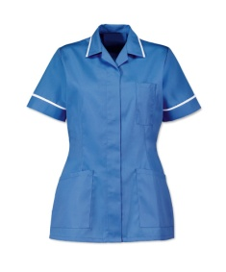
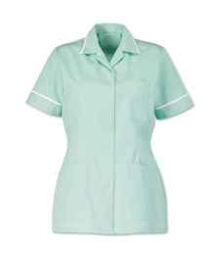
Laundry Assistants
Staff Nurses

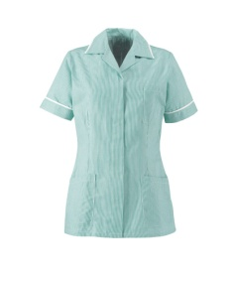
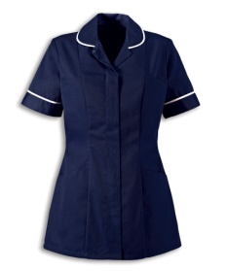
Manager/Deputy Manager
Domestic Assistants

Ward Clerk, Secretaries &
Finance Officer

You may also see other staff members in and around the Hospital, including:
- Kitchen staff who wear a white chef's tunics
- Daycare/Activities who wear a purple polo shirt
- Maintenance Engineer who wears a navy polo shirt
- Physiotherapist and Physiotherapist Assistant who wear light blue polo shirts.
- Gardener who wears a brown polo shirt
- Handyman who wears blue overalls

The Manager
The Manager, Maxine Winch, has been a Registered General Nurse since 1991 and has worked in a number of care homes. She has worked at Holbeach Hospital since 2011, working as the Deputy Manager until becoming Manager in 2015.
Lesly Pointer is our Deputy Manager

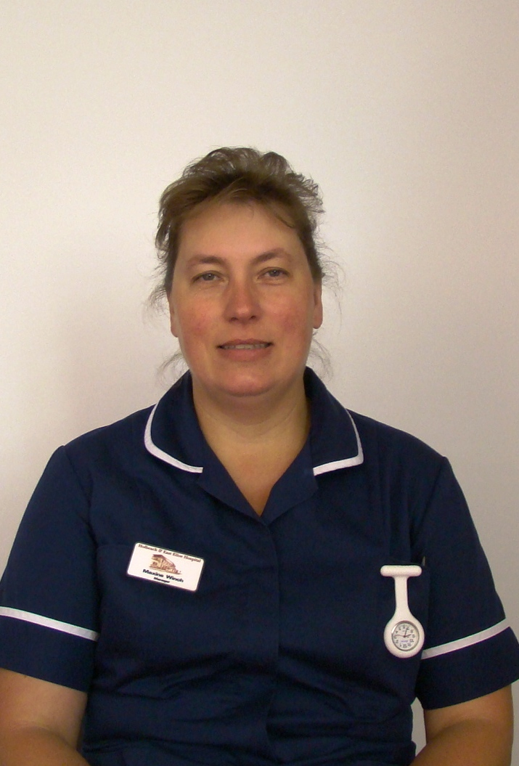

5. Fire Policy & Electrical Equipment
Your safety and security is of paramount importance to us. There are designated fire exits in all areas of the building and fire extinguishers are fixed in accessible locations. The Maintenance Engineer checks the fire extinguishers on a monthly basis and the fire alarm is tested weekly. All fire emergency exits should be kept clear at all times, including corridors and the lift area. We have a number of fire doors designed to restrict the spread of fire and smoke in the event of any incident. These are regularly tested and maintained to ensure they function correctly.
What should visitors do in the event of the fire alarm being sounded (including fire drills)?
- When entering the building please make yourself aware of the nearest fire escape routes.
- On hearing the alarm, please make your way to the nearest fire exit and proceed to the assembly point outside the main entrance.
- Please move away from the building and await further instructions; if it is a drill you will be informed.
In the case of fire, the fire brigade will be called and the service users will be moved to a place of safety, either within or outside the building to the designated fire assembly points.
Electrical Equipment
If you wish to bring in any electrical equipment from home, for example hairdryers etc, please inform the Maintenance Engineer before use so that he can ensure all safety checks have been carried out and it is PAT tested.
Chiropody Service
Our Chiropodist visits approximately every six weeks and currently charges £15 for nail trimming and footcare.

Eye Testing Service
Visioncall visit Holbeach Hospital two to three times a year. They provide free NHS eye testing and can provide spectacles at no cost if you are in receipt of pension credit.

Newspaper delivery service
We can arrange for you to receive your usual local or national newspaper or magazine, delivered to your room. Please ask the nurse on duty or a member of the care staff if you would like this to be arranged.

Pocket Money
Some residents find it easier to keep money in the secretarial office safe, which the secretarial staff can then use to pay for newspapers, chiropody and hairdressing on your behalf without disturbing you with bills on a weekly basis. If you would prefer this option please let a member of staff know. We will need the contact details of somebody we can ring on your behalf to keep your pocket money account topped up.

Trolley Shop
The League of Friends regularly brings round a trolley shop and residents can purchase sweets and toiletries etc.

Hospital Appointments
If you have a hospital appointment, Helen our Ward Clerk can arrange the transport you require. If you need to be escorted and friends/family are not available, a member of staff can escort you at an extra cost of £10 per hour
2. Dayrooms, family room and activities
We have three attractive and spacious dayrooms which act as a social hub and allow our residents and their families to come together and enjoy meals and activities. A mobile library visits regularly and a selection of books is always available in our dayroom two. The Dayrooms are where the majority of our activities and entertainment takes place. We provide a regular agenda of entertainment throughout the year organised by The League of Friends, and family and friends are welcome to attend with our residents. This might include singers, bands, orchestras and a range of other entertainers. These events are optional, and residents are able to stay in their bedrooms if they prefer.
A range of activities are also held within our Day Care facility and two activity organisers also go and assist each resident with whatever they wish to do on a weekly basis. Jackie and Maggie run various activities on a Friday, including fitness, crafts and music, and regularly arrange day trips.
We provide a family room where families are welcome to sit down together during difficult times and tea and coffee making facilities are provided free of charge. Families are also welcome to make a hot beverage in our family room after long journeys etc or to discuss private matters.
Church representative are in regular contact with us to provide pastoral care and support. A church service is held on the 1st Thursday of each month at 2:30pm in Dayroom
3. Visitors
We have an open-door policy towards visitors at Holbeach and East Elloe Hospital Trust. We believe friends and relatives should be able to visit residents at any time during the day so we do not have restrictive visiting times. Friends and family are welcome to visit residents in their bedroom or one of our dayrooms. Visitors toilets are available down the main corridor.
Small pets are also allowed to visit but please speak to the Manager if you would like to bring in any pets to discuss arrangements before coming. Dogs must be well behaved and kept under control at all times.
We ask that all visitors sign the visitors book in the entrance foyer and sign out when they leave so that we have an accurate list of who is in the building in case of emergency. There are no restrictions on how many visitors can attend each time but please respect other residents in the day room who may prefer a peaceful environment. This is a home from home facility so we respect all of our residents’ rights to privacy and dignity.
The family room can be used to provide a place to stay overnight for a family member who wishes to remain close to a loved one nearing the end of their days. When the room is in use, a sign will be displayed on the door.

4. Optional extras and how to book them
There are other optional extras which are available at an additional cost, including a daily newspaper delivery service, an onsite hairdresser and a Chiropodist who visits every 6 weeks. We also have a visiting optician service. If you wish to arrange any of these optional extras, please inform the nurse on duty who will organise them for you.
Hairdressing Service
Our hairdressing service is operated every Wednesday from 9.30 am until 4pm. Christine welcomes clients from both the nursing home and the Anne Waltham Unit.
Hairdressing Price List
Shampoo and Set (or with Cut) £7.00-£9.00
Wash and Blow Dry (or with Cut) £8.50-£9.00
Dry Cut £7.50
Perm £29.50
Gents Cut and Trim £7.00
Moustache £1.50
Eye Brows £1.00
*For all appointments requested, clients must have money available to cover the cost at the time of booking.

