Review Sheet
Last Reviewed Last Amended Next Planned Review in 12 months, or
16 Jan '20 16 Jan '20 sooner as required.
Business impact | These changes require action as soon as possible.  HIGH IMPACT
Reason for this review | Scheduled review
Were changes made? | Yes
Summary: | This policy supports with how to deal with subject access requests and the process to follow. It has been reviewed and with some content changes, namely the explanation of the timescales that apply for responding to a subject access request which has been updated in line with recent guidance. References have also been checked to ensure they remain current.
Relevant legislation: | - General Data Protection Regulation 2016  - Data Protection Act 2018
Underpinning knowledge - What have we used to ensure that the policy is current: | - Author: Information Commissioner's Office, (2018), Rights of access. [Online] Available from: https://ico.org.uk/for-organisations/guide-to-the-general-data-protection- regulation-gdpr/individual-rights/right-of-access/ [Accessed: 16/1/2020]
Suggested action: | - Discuss in supervision sessions  - Notify relevant staff of changes to the policy  - Encourage sharing the policy through the use of the QCS App  - Establish process to confirm the understanding of relevant staff  - Arrange specific meetings to discuss the policy changes and implications  - Ensure that the policy is on the agenda for all team meetings and staff handovers
Equality Impact Assessment: | QCS have undertaken an equality analysis during the review of this policy. This statement is a written record that demonstrates that we have shown due regard to the need to eliminate unlawful discrimination, advance equality of opportunity and foster good relations with respect to the characteristics protected by equality law.

1. Purpose
  - To explain Subject Access Requests and to ensure that all staff at Holbeach Hospital & Nursing Home know how to recognise and deal with the receipt of a Subject Access Request.
  - To support Holbeach Hospital & Nursing Home in meeting the following Key Lines of Enquiry:

Key Question Key Lines of Enquiry
W2: Does the governance framework ensure that responsibilities are clear and that quality performance, risks and regulatory requirements are understood and managed?
WELL-LED

  - To meet the legal requirements of the regulated activities that Holbeach Hospital & Nursing Home is registered to provide:
    - General Data Protection Regulation 2016
    - Data Protection Act 2018
2. Scope
  - The following roles may be affected by this policy:
    - All staff
  - The following Service Users may be affected by this policy:
    - Service Users
  - The following stakeholders may be affected by this policy:
    - Family
    - Advocates
    - Representatives
    - Commissioners
    - External health professionals
    - Local Authority
    - NHS
3. Objectives
  - This policy will assist with defining accountability and establishing ways of working in terms of responding to Data Subjects exercising their rights.
  - This policy will enable GDPR compliance at Holbeach Hospital & Nursing Home by ensuring that Subject Access Requests received from Data Subjects, including Service Users, are dealt with appropriately by staff and by Michael Brett, Trustee and Financial Director or a designated other responsible for GDPR compliance at Holbeach Hospital & Nursing Home.
  - This policy will facilitate the process of making a Subject Access Request for the benefit of Data Subjects, including Service Users.

4. Policy
  - Holbeach Hospital & Nursing Home will ensure that the policy entries below are reviewed, understood and complied with by all staff at Holbeach Hospital & Nursing Home. Holbeach Hospital & Nursing Home acknowledges that if its processes differ from those set out in the policy, it will modify them to the extent necessary to reflect its processes and procedures.
  - Holbeach Hospital & Nursing Home will ensure that it has appointed either a Data Protection Officer (DPO) if required to do so, or has specified who will be responsible for Data Protection within Holbeach Hospital & Nursing Home. Their name and contact details will be publicised so that staff know who to contact should any queries or Subject Access Requests be made. Holbeach Hospital & Nursing Home will ensure that the details are kept up-to-date and that those up-to-date details are reflected in this policy and associated procedures. The Trustee and Financial Director is Michael Brett, whose contact details are 01406 490836, mike.brett@holbeach-hospital.org.uk.
  - The DPO at Holbeach Hospital & Nursing Home will read and understand this policy and procedure and adhere to the Subject Access Request process every time a Subject Access Request is received.
  - Holbeach Hospital & Nursing Home understands that an individual is legally entitled to require an organisation to provide access to, or copies of, all of that individual’s personal data held by the Organisation. This is known as a “Subject Access Request”.
  - At a high level, personal data is any information which identifies a living individual or could be used to identify that person. It includes first name and surname, email address, address, date of birth, medical and health records, Care Plans, photographs, CCTV images, right to work documentation, marriage certificates, National Insurance number, and political and religious views amongst others.
  - Holbeach Hospital & Nursing Home is not entitled to charge a fee to respond to the Subject Access Request (unless a person makes manifestly unfounded or excessive Subject Access Requests).
  - Holbeach Hospital & Nursing Home must respond to the Subject Access Request as soon as possible and no later than within one calendar month from the first day after the Subject Access Request was received. If the following month is shorter and there is no corresponding calendar date (e.g. the Subject Access Request is received on 31 May but there is no 31 June), the date for response is the last day of the following month (e.g. 30 June). If the corresponding date falls on a weekend or a public holiday, the response must be sent by the next working day. Holbeach Hospital & Nursing Home acknowledges that it may be simplest to adopt a 28-day default response period so that it has a consistent approach to responding to Subject Access Requests throughout the year.
  - We understand that the Subject Access Request can be made to anybody in Holbeach Hospital & Nursing Home. It is therefore possible that any member of staff may receive a Subject Access Request on behalf of Holbeach Hospital & Nursing Home.

5. Procedure

Template Subject Access Request Letter
Holbeach Hospital & Nursing Home will consider providing the template letter of Holbeach Hospital & Nursing Home to Data Subjects, potentially via its website.
If Holbeach Hospital & Nursing Home provides the template letter, it will notify the Data Subjects that they are not obliged to use the template letter and that they may ask Holbeach Hospital & Nursing Home in writing by any means for access to their Personal Data. Holbeach Hospital & Nursing Home will also notify the Data Subjects that they do not need to use any particular form of words to make a Subject Access Request.

Process Map Stage 1 - Maintaining a log of Subject Access Requests
Holbeach Hospital & Nursing Home will maintain a log of the Subject Access Requests it receives, setting out the dates on which the requests are received and the final response sent, together with any intermediary steps taken before sending a final response (e.g. request for identification proof or further information in respect of the data).
If Holbeach Hospital & Nursing Home fails to respond to the request in accordance with GDPR timescales, this must also be noted together with an explanation of the failure and steps taken to avoid such failure in the future.

Process Map Stage 2 - Acknowledge Subject Access Request
Holbeach Hospital & Nursing Home acknowledges that it is best practice for Holbeach Hospital & Nursing Home to acknowledge receipt of the Subject Access Request, although this is not strictly necessary.

Process Map Stage 3 - Confirmation of Identity
    - Holbeach Hospital & Nursing Home understands that it will only respond to a Subject Access Request if it is confident of the identity of the applicant
    - Holbeach Hospital & Nursing Home understands that it must be reasonable in terms of what it asks for and that it must not ask for a significant amount of extra information if the identity of the person making the request is obvious, which is more likely to be the case if Holbeach Hospital & Nursing Home has an ongoing relationship with that person. If, for example, an existing employee or Service User makes the request, Holbeach Hospital & Nursing Home acknowledges that it is likely it will be able to confirm their identity easily
    - If, however, Holbeach Hospital & Nursing Home receives a request from an individual it does not recognise or the individual's email address/postal address has changed since the last dealings with them, Holbeach Hospital & Nursing Home will consider seeking further proof of identity such as a recent utility bill or copy of a driving licence or passport
    - In this scenario, the one-month time period to respond will commence only once Holbeach Hospital & Nursing Home has received the proof of identity. Holbeach Hospital & Nursing Home will not delay in asking for further proof

Process Map Stage 4 - Checking if other information is required to find the records requested
    - Holbeach Hospital & Nursing Home is entitled to ask for further information it reasonably needs in order to comply with the Subject Access Request, although it must not delay responding to a Subject Access Request unless it requires more information to find the data in question
    - Holbeach Hospital & Nursing Home will not require the applicant to narrow the scope of the request (they are entitled to ask for all the information Holbeach Hospital & Nursing Home holds), but Holbeach Hospital & Nursing Home may ask them to provide some context around the information they are seeking such as relevant dates or if they want a particular document or type of document (e.g. letter, email, application form), which may help Holbeach Hospital & Nursing Home locate the data
    - Holbeach Hospital & Nursing Home will not delay in asking for further information and will be clear about what details are needed. Provided Holbeach Hospital & Nursing Home does that, and it needs the additional information in order to be able to comply (rather than it being a tactic to delay timescales), the one-month time period will begin when Holbeach Hospital & Nursing Home receives the information

Process Map Stage 5 - Gathering information
    - Collating all relevant information will be the most time-consuming task. Holbeach Hospital & Nursing

Home will consider which departments may hold personal data and whether that personal data can be accessed centrally by one individual or team
    - The fewer people who are involved in locating the data, the less impact it will have on the day-to-day business of Holbeach Hospital & Nursing Home
    - Holbeach Hospital & Nursing Home will consider how to search for the data. For example, does the Data Subject use a nickname or alternative name which would also need to be searched?

Process Map Stage 6 - Considering whether an exemption applies
Under GDPR, member states are entitled to restrict the application of individuals’ rights (including Subject Access Requests). The Data Protection bill entitles a Data Controller to restrict Subject Access Requests to the extent that the restriction is (having regard to the fundamental rights and legitimate interests of the Data Subject) necessary and proportionate to:
    - Avoid obstructing an official or legal inquiry, investigation or procedure
    - Avoid prejudicing the prevention, detection, investigation or prosecution of criminal offences or the execution of criminal penalties
    - Protect public security
    - Protect national security
    - Protect the rights and freedoms of others
These are relatively narrow in scope, but Holbeach Hospital & Nursing Home will consider them when responding to a Subject Access Request. If in doubt as to whether an exemption applies, Holbeach Hospital & Nursing Home will seek legal advice.
If a request is manifestly unfounded or excessive, Holbeach Hospital & Nursing Home may charge a reasonable fee or refuse to act on the request, but Holbeach Hospital & Nursing Home will have to demonstrate that the request is unfounded or excessive. If Holbeach Hospital & Nursing Home processes large volumes of data, it is entitled to ask the Data Subject to specify the information or processing activities to which the request relates (as referred to above).

Process Map Stage 7 - Maintaining confidentiality
If personal data relating to other individuals is included in the documents that will be provided pursuant to the Subject Access Request, it will need to be redacted. Holbeach Hospital & Nursing Home
may alternatively obtain consent from the Data Subject to disclose the personal data, but that may be more time consuming than redaction.

Process Map Stage 8 - Reviewing what data has been requested
In some cases, the Data Subject may only request a copy of his or her personal data. They are entitled, however, to also request the following information:
    - The purposes of and legal basis for the processing
    - The categories of personal data that are processed
    - The recipients or categories of recipients to whom the personal data has been disclosed (including recipients or categories of recipients in third countries or international organisations)
    - The period for which it is envisaged that the personal data will be stored or, where that is not possible, the criteria used to determine the retention period
    - The existence of the Data Subject’s rights to request:
      - Rectification of personal data; and
      - Erasure of personal data or the restriction of its processing
    - The existence of the Data Subject’s right to lodge a complaint with the Information Commissioner's Office and the contact details of the Information Commissioner's Office
    - Communication of the personal data undergoing processing and any information about its origin If the above information is requested in the Subject Access Request, it must be provided.

Process Map Stage 9 - Retention of information
Holbeach Hospital & Nursing Home will consider keeping a copy of the information provided to the Data Subject until it receives confirmation from the Data Subject that it does not require any further information, or for a period of 6 months from completion of the request, whichever happens first.

Training
Holbeach Hospital & Nursing Home will circulate this policy to all staff. Holbeach Hospital & Nursing Home

will consider whether providing training to staff in respect of Subject Access Requests and this policy would be beneficial.
6. Definitions

Data Protection Act 2018
    - The Data Protection Act 2018 is a United Kingdom Act of Parliament that updates data protection laws in the UK. It sits alongside the General Data Protection Regulation and implements the EU's Law Enforcement Directive

Data Subject
    - The individual about whom Holbeach Hospital & Nursing Home has collected personal data

GDPR
    - General Data Protection Regulation (GDPR) (EU) 2016/679 is an EU regulation relating to data protection and privacy. It was adopted on 14 April 2016 and after a two-year transition period became enforceable on 25 May 2018

Personal Data
    - Any information that identifies a living person including but not limited to names, email addresses, postal addresses, job roles, photographs, CCTV and special categories of data

Process or Processing
    - Doing anything with personal data, including but not limited to collecting, storing, holding, using, amending or transferring it. An organisation does not need to be doing anything actively with the personal data - at the point it collects it, it is processing it

Special Categories of Data
    - Has an equivalent meaning to “Sensitive Personal Data” under the Data Protection Act 1998. Special categories of data include but are not limited to medical and health records and Care Plans (including information collected as a result of providing health care services) and information about a person’s religious beliefs, ethnic origin and race, sexual orientation and political views
Key Facts - Professionals
Professionals providing this service should be aware of the following:
    - All staff at Holbeach Hospital & Nursing Home will follow the guidelines set out in this policy to ensure that Subject Access Requests are dealt with appropriately and in compliance with GDPR
    - Data Subjects can use the template request letter provided in the form attached to this policy, or can request data in writing in other means. All Subject Access Requests must be responded to, irrespective of the form of communication
Key Facts - People affected by the service
People affected by this service should be aware of the following:
    - If a Data Subject, including a Service User, wishes to make a Subject Access Request to Holbeach Hospital & Nursing Home, they can use the template request letter provided. They do not have to use the template request letter and can instead make the Subject Access Request in writing by any other means
Further Reading
There is no further reading for this policy, but we recommend the 'underpinning knowledge' section of the review sheet to increase your knowledge and understanding.

Outstanding Practice

To be ‘ outstanding ’ in this policy area you could provide evidence that:
    - Holbeach Hospital & Nursing Home provides training to all staff to ensure that they understand how to recognise and deal with a Subject Access Request
    - Holbeach Hospital & Nursing Home creates a detailed log for GDPR compliance, including a log of all information relevant to Subject Access Requests received
    - The wide understanding of the policy is enabled by proactive use of the QCS App

Forms

The following forms are included as part of this policy:
Title of form | When would the form be used? | Created by
Template Subject Access Request Letter - GDPR05 | When a Data Subject submits a Subject Access Request. | QCS
Subject Access Request Process Map - GDPR05 | This form can be used by each organisation's Data Protection or Privacy Officer (or similar) each time a Subject Access Request is received. The process map must be reviewed alongside the corresponding procedure entries. | QCS

Holbeach Hospital & Nursing Home
Boston Road North, Holbeach, Spalding, Lincolnshire, PE12 8AQ
Page 1/1
Template Subject Access Request Letter - GDPR05
This policy is Copyright © Quality Compliance Systems Ltd. 2018 (Last updated 2020) and is only licensed for use with a current Licence Certificate. If you have a current Licence Certificate, it can be accessed in your online account. Use without a current Licence Certificate is strictly prohibited.

Michael Brett, Trustee and Financial Director Holbeach Hospital & Nursing Home
Boston Road North Holbeach
Spalding Lincolnshire PE12 8AQ

Date:

Dear Michael Brett

Subject Access Request under the General Data Protection Regulation 2016

I am writing to make a Data Subject Access Request pursuant to the General Data Protection Regulation 2016.

Scope of Request
[This is a general request that relates to any personal data processed about me by or on behalf of Holbeach Hospital & Nursing Home].
[OR]
I only require information in respect of the following:
[Insert any information you think would help us to find what you are seeking, or let us know if there is something in particular you require]

[Locating the data]
[Please only provide documents and emails that were created and/or sent between [Insert date range].] [Please only provide emails that were sent between [Insert names].]

Yours sincerely,

[Please enter your full name]

Subject Access Request Flow Chart

1 2

Maintain a log of requests.
Acknowledge subject access request from data subject.

No ID
Provided
3a
Request further ID - clock stops.

More ID Needed
3

Decide whether
further proof of ID is needed.

Notify data subject that
3b subject access request has been closed. Log decision / action taken.
Sufﬁcient ID
Received
ID
Sufﬁcient

4
Decide whether further information is required to be able to respond to the subject access request.

Further information not received
4a
Request further information from data subject - clock stops.

More information needed
No grounds for requesting more information

Notify data subject that the
4b subject access request is closed and log decision / action taken.
Further information provided

Collate all relevant information/liaise with each relevant team in order to respond to the subject access request.
5

6
Consider whether any
exemptions apply.
7

Ensure other data subjects’
personal data is not visible or traceable.

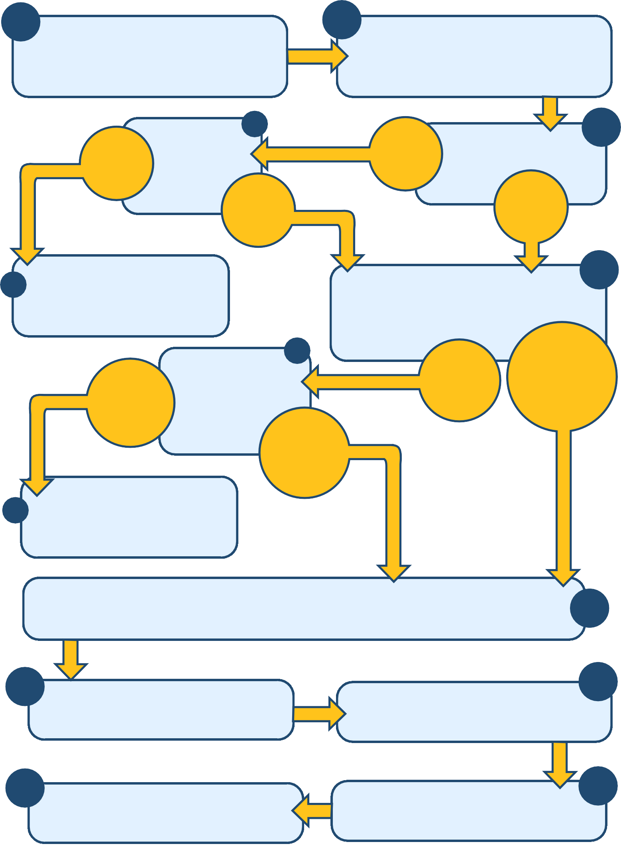
9 Log that subject access request has been ﬁnalised, and link to stage 1.
Finalise letter to data subject and 8
securely send copy of all information requested.

